Verify Environment Access

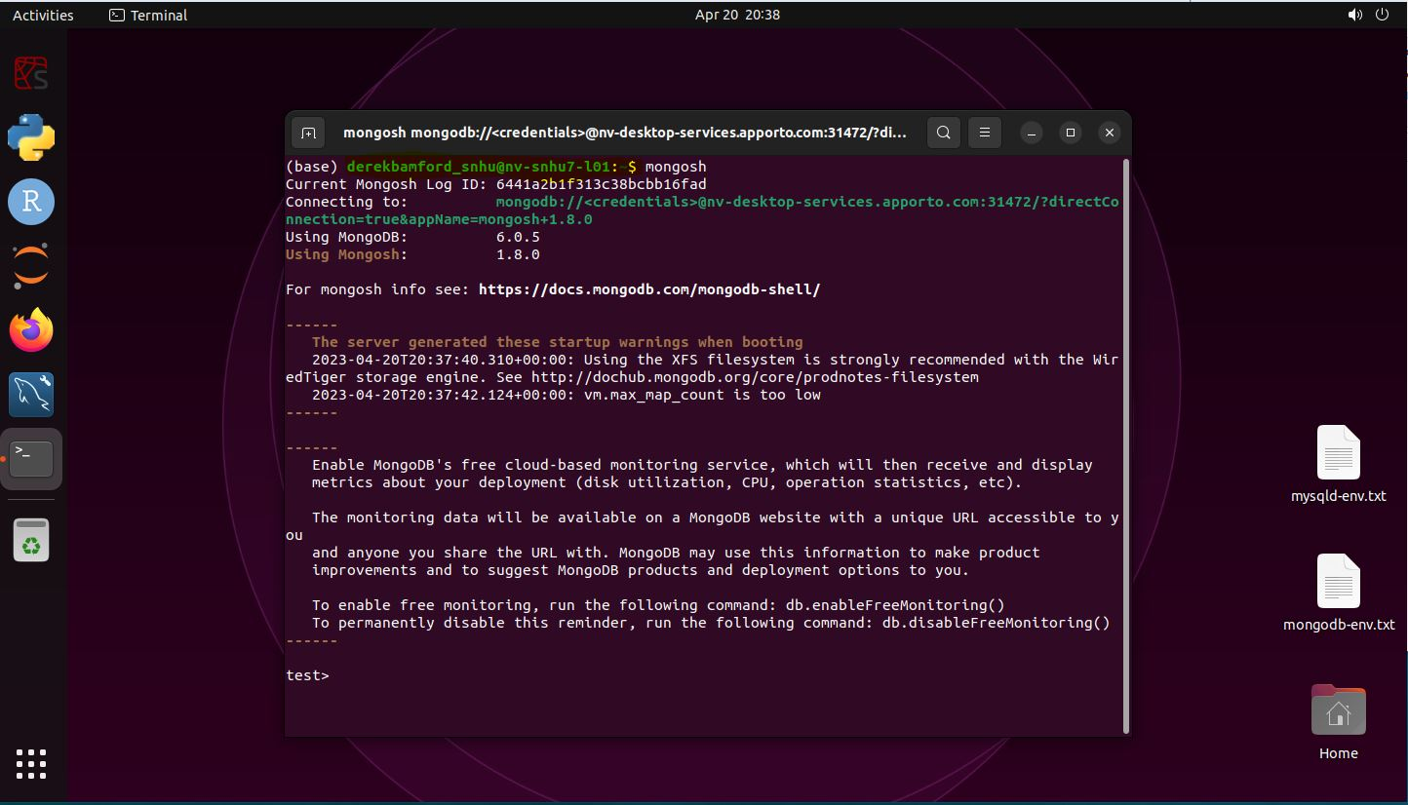

Mongo Shell Commands: Retrieve Document

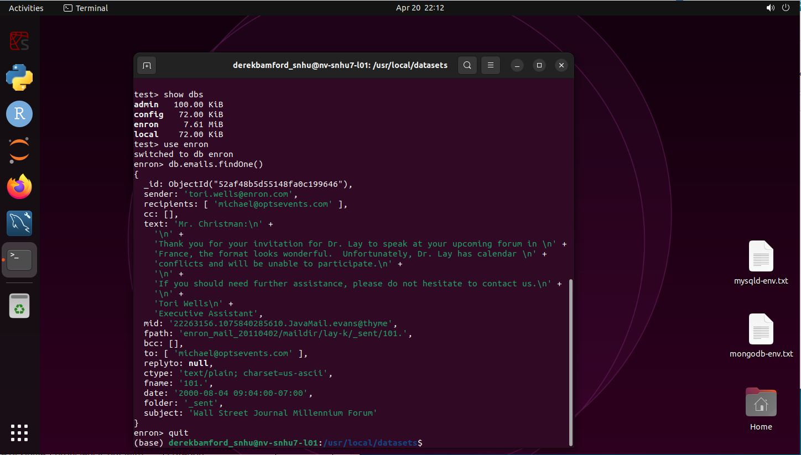

Mongo Shell Commands: Find Size of Single Document

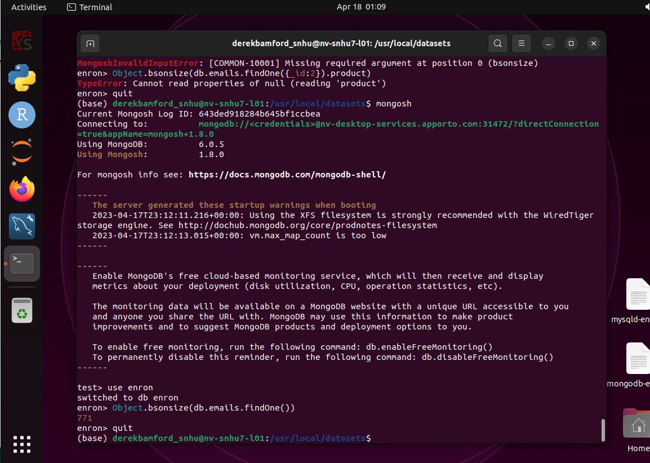

Mongo Shell Commands: Find Size of Collection of Documents

